THE ROLE OF FOREIGN DIRECT INVESTMENTS IN POLAND’S ECONOMIC DEVELOPMENT
Ewa Bojar
Jakub Bis
Introduction
The significance of investments for economic development was analysed since the beginning of the heyday of economic thought. Economists appreciate the role of investments in stimulating economic growth. Investments can influence the labour market (demand for labour, counteracting labour force migrations), transfer new technical, technological and organizational solutions, new management methods and styles; investments can also affect work culture and shape behaviours, as well as force employees to improve their professional qualifications and skills. Moreover, investments can motivate the authorities to undertake substantial infrastructural improvements and improve the quality of services performed by their subordinate departments and agencies.
Investment activity is a manifestation of economic activities carried out by the investor and the factor activizing other entities. Usually, visible results of investment activity are as follows (BOJAR, 2001, p. 31):
- a growth in the property of enterprises, regions, and the country as a whole;
- domestic product growth;
- an increase in the employment of the factors of production (labour force employment, increased demand for raw materials, semi-finished products, cooperation services, etc.);
- an increase in revenue of the population, which in turn generates additional demand for goods and direct services;
- an increase in revenue of the state and local self-governments, which enables better performance of their functions without raising tax rates.
Therefore, one can state that investments are the most important factor of social and economic development. The scope of this paper is limited to investments made in Poland and the authors analyze a specific form of investing, i.e. foreign direct investments (FDI).
Investments as the main factor of economic development
K. Rittenbruch (1968, p. 48) claims that export-oriented investments, termed as "base activity", constitute the base for economic development. Economic base theory proves that socio-economic development depends on the exogenous factor (external demand) and not on volatile endogenous factors (FILIPIAK, KOGUT, SZEWCZUK, ZIOŁO, 2005, p. 39). Export not only increases investments and imports, but also creates new jobs, thus increasing domestic consumption. This activates the multiplier effect, a phenomenon having the feedback nature. The size of multiplier effects is closely connected with the kind of performed activity and enterprises operating in a given country. There are two types of multiplier effects, i.e. supply-related effects which result from additional demand generated by enterprises, and income effects (an increase in employees’ income results in a growth of purchasing power of the population). Additional demand for products and services generates new jobs in newly established enterprises. With the multiplier effects revenues of the state budget are growing and thus the authorities have more funds available for infrastructural investments and improvements in the quality of public services.
P.N. Rosenstein-Rodan (1943, p. 202-211) noticed that developing economies often cannot overcome a development threshold which would enable them achieve internal economic revival or sustain a development process. As a solution to this problem Rosenstein-Rodan proposed the theory of the "big-push". Rosenstein-Rodan suggested that underdeveloped economies require substantial amounts of autonomous investments, mainly infrastructural investments, undertaken irrespectively of the current size of demand and the level of economic activity. According to this theory, the big push should be based on the public funding sources.
It seems that Rosenstein-Rodan underestimated invisible market forces. He argued that the state intervention in the form of government guarantees and big investment projects is the best recipe for the mobilization of capital. This balanced approach to development, with the growing disparities between regions, has met a strong wave of criticism and finally gave impetus to the creation of new theories – the theory of unbalanced growth. In the second half of the twentieth century, a search for mechanisms which would effectively allow underdeveloped regions to decrease economic development gaps with the leaders was started. The precursor of this search was A.O. Hirschman (1958) who claimed that economic development can be achieved thanks to the surplus generated as a result of investments in development bottlenecks. Capital generated as a result of these investments, as well as capital gained from export, could then be re-invested thus stimulating economic growth. Therefore developing countries should use adequate investment incentives in order to stimulate development of particular sectors of economy. Thanks to this approach new investments will produce the multiplier effects in the economy, as mentioned above. At the same time Hirschman forewarned of social and psychological barriers of economic development.
He argued that lack of ability to take on challenges and a low level of entrepreneurship in underdeveloped regions can effectively squander a chance to achieve the convergence created by investments.
N. Kaldor (1970), like K. Rittenbruch and A.O. Hirschman, stressed the key role of export in accelerating economic growth. He argued that export, thanks to internal and external savings, contributes to improving the efficiency of economy. If wages are not growing as fast as productivity, the competitive advantage of the country is growing, which in turn stimulates the influx of foreign investments and, consequently, economic growth.
To recapitulate, although foreign direct investments per se are not a remedy for economic development disparities, they offer chances for economic revival. In accumulating foreign direct investments, internal social and economic transformations and needed reforms should also be implemented. Rising from underdevelopment should not be dependent exclusively on external factors such as foreign direct investments since the outflow of foreign investments can deteriorate economic situation. The country which relies too much on foreign investments and pays little attention to internal reforms is exposed to a serious risk of loosing its natural ability to develop.
Foreign direct investments in Poland
Poland, with an average annual economic growth rate running in the years 1995-2012 at the level of 4.7 %, seems to be an interesting country for foreign investors. Due to the large number of inhabitants exceeding 38.1 million, diversified sectors of economy, and good access to both western and eastern European markets, Poland attracts substantial amounts of foreign capital. As of the end of 2012, the cumulated value of foreign direct investments (FDI) in Poland, calculated as the current, accounting value of made investments, amounted to 156.1 billion EUR. What distinguishes Poland’s economy is that it is immune to disturbances on international markets. This is mainly due to high domestic demand and big export volume. Quite a sizeable group of exporters are foreign investors attracted to Poland by relatively low labour costs and availability of skilled and productive workforce. Moreover, investors value stable business environment, low inflation, and lasting economic growth (cf. data presented in table 1 below). In recent years, Poland managed to improve significantly its infrastructure and Polish enterprises continue to increase their innovativeness by implementing more and more modern technologies. In Poland, there are nearly 2 million students; almost 50% of the population aged between 19 and 24 are students. In 2010, Poland had 480,000 university graduates. The number of third cycle students is also growing. In 2010, at Poland’s universities there were enrolled as many as 37,500 Ph.D. students.

Table 1. The basic Poland’s macro-economic data in the years 2002-2012
Variable | 2002 | 2003 | 2004 | 2005 | 2006 | 2007 | 2008 | 2009 | 2010 | 2011 | 2012
GDP (bln PLN)* | 809 | 843 | 925 | 983 | 1,060 | 1,177 | 1,275 | 1,344 | 1,415 | 1,522 | 1,595
GDP increase (%)* | 1.4 | 3.9 | 5.3 | 3.6 | 6.2 | 6.8 | 5.1 | 1.8 | 3.9 | 4.3 | 2.0
FDI influx  (bln EUR)** | 4.4 | 4.1 | 10.2 | 8.3 | 15.7 | 17.2 | 10.1 | 9.9 | 6.7 | 13.6 | 2.7
Unemployment (%)* | 18.0 | 20.0 | 19.0 | 17.6 | 14.8 | 11.2 | 9.5 | 12.1 | 12.4 | 12.5 | 13.4
Export  (bln EUR)* | 43.5 | 47.5 | 59.7 | 71.4 | 88.0 | 102.8 | 116.2 | 98.2 | 120.4 | 135.3 | 143.5
Import  (bln EUR)* | 58.5 | 60.4 | 71.4 | 81.2 | 100.8 | 120.4 | 142.5 | 107,5 | 134.2 | 150.5 | 154.0
Foreign trade turnover  (bln EUR)* | 102.0 | 107.9 | 131.1 | 152.6 | 188.7 | 222.2 | 258.7 | 205.7 | 254.6 | 285.8 | 297.5
Foreign trade balance  (bln EUR)* | -15.0 | -12.8 | -11.7 | -9.8 | -12.9 | -18.6 | -26.2 | -9.3 | -13.8 | -14.7 | -10.6
CPI  (preceding year = 100)* | 101.9 | 100.8 | 103.5 | 102.1 | 101.0 | 102.5 | 104.2 | 103.5 | 102.6 | 104.3 | 103.7
Source: *Central Statistical Office of Poland, **National Bank of Poland

According to World Investment Report, the most important publication on global FDI, Poland is classified in the first quartile of countries in terms of the value of FDI Attraction Index, a measure of the real success in attracting foreign direct investment over the past three years. Moreover, according to Attractiveness Survey, a report published in 2010 by Ernst & Young European, Poland is most often indicated by managers of foreign enterprises as one of the best locations for new investments in Europe. In addition, in terms of the number of new jobs Poland is ranked fifth in Europe and eight among other European countries attracting foreign investments. According to the report, in terms of foreign direct investments, the most important industries are: automotive industry, business services, and electronics. Both reports state that Poland’s economy has very sound and stable foundations. Poland is not threaten with financial crisis. Inflation is kept at a safe level and the rate of unemployment is slightly lower than in other EU countries. It is unlikely that public dept, which is considerably lower than the EU average of 88% of GDP, will exceed the limit of 60% of Poland’s GDP. None of these indices shows a significant fluctuation which could point to the danger of deteriorating economic situation of the Polish economy. Poland remains an attractive market for potential foreign investors and the country is constantly improving its position in economic competitiveness rankings published by the World Economic Forum (presently Poland is ranked 41st among 144 countries). The growth in the competitiveness of Poland’s economy can be attributed to significant improvements in the transport infrastructure, greater transparency of the government bureaucracy, and intensification of research-and-development activities carried out by enterprises.
As of the end of 2012, in Poland operated 25,914 enterprises with foreign capital, which was a 4% increase as compared to 2011. The most of them were limited liability companies (92.8%), 3.9% were joint-stock companies, 2.2% were limited partnerships, and 0.4% of enterprises with foreign capital were run in other available legal forms. Only 0.7% of foreign investors established branch offices in Poland.
For years, the most attractive sectors for foreign investors have been trade and car repair, which attracted 28.1% of foreign capital, and manufacturing (19.7%).
Mazowieckie Voivodeship with its capital Warsaw is the leader in attracting foreign direct investments. In 2012, this region has attracted 38.5% of foreign investors investing in Poland. In Lower Silesian Voivodeship were based 9.2% enterprises with foreign capital, in Silesian Voivodeship – 9.1%, and in Wielkopolskie Voivodeship – 8.8%. In 2012, like in 2011, 85.1% of joint ventures were entities in which foreign capital exceeded 50% of the core capital. In this group 80.6% of enterprises were businesses wholly owned by foreign investors. In the group of entities in which foreign capital prevails, 87.1% were entities in which more than 50% of core capital was owned by just one foreign shareholder.
The sector of modern business services with foreign capital in Poland
India, with a 40% market share, is the world leader in offshore outsourcing and captive offshoring. However, according to latest forecasts, India’s position will weaken in favour of other locations, including eastern and central European countries. In this region Poland is by far the leader in offshore outsourcing and captive offshoring, both in terms of the number of operating entities, and employment size. According to the global ranking 2014 Tholons Top 100 Outsourcing Destinations, the city of Kraków overtook Dublin and was ranked ninth among the most attractive European locations for modern business services. Two other Polish cities were also included in the ranking, Warsaw was ranked 32nd and Wrocław 65th amongst the top 100 locations.
In Poland, there are 470 service centres with foreign capital owned by 325 investors. All these centres employ in total 128,000 people. Over the past two years, the number of employees in these service centres has increased by more than 50%. An average employment is 273 people and is constantly growing. Approx. 95% of employees work in ten biggest business services centres which are based in Kraków, Warsaw, Wrocław, Tri-City (Gdańsk, Gdynia, Sopot), Łódź, Katowice agglomeration, Poznań, Bygdoszcz, Szczecin, and Lublin. According to research carried out by the Association of Business Service Leaders (ABSL), 9 out of 10 surveyed service centres declare that they have plans to increase employment by the end of 2015. 90% of employees working in these centres are full-time employees.
The biggest foreign investors operating in the sector of modern business services are: France Telecom with more than 6,000 employees in several cities, Capgemini with over 4,000 employees in service centres based in Kraków, Katowice and Wrocław, IBM (above 3,500 employees in several cities), General Electric (over 3,000 employees in Gdańsk, Warsaw and Łódź), and Hewlett-Packard (more than 2,000 employees in a Wrocław-based service centre). According to ABSL’s study, the biggest number of employees work in service centres operating in the IT sector 29%), finance and accounting (22%), and in banking, insurance and financial services (14%). The sector of modern business services in Poland specializes in services offered to businesses based in European countries; 68% of their customers are companies from western Europe.
Map 1. Employment in foreign service centres in Poland in 2013 (in thousands)
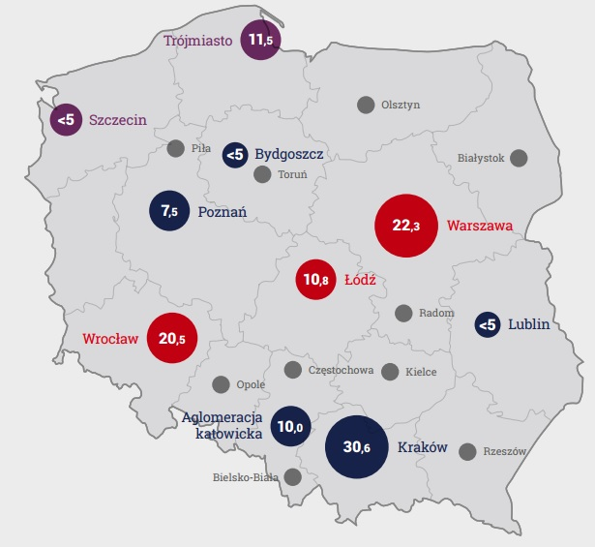
Source: Sektor nowoczesnych usług biznesowych w Polsce, Association of Business Service Leaders in Poland

The development of modern business services sector in Poland contributed to the increase in the number experienced managers and employees with several years of work experience. Interestingly enough, the bulk of the centres’ employees are university graduates and students. Although the sector is growing at an impressive rate of 20% per annum, it seems legitimate to say that it is now in the phase of transition from the youth stage to the stage of maturity. One of the most conspicuous symptoms of this process is the growing number of industry organizations and development of highly specialized centres. Many analysts predict that the prospects for continuous development of offshoring services in Poland are promising. It is expected that foreign investments in the field of advanced, knowledge-based services which generate high added value, will increase notably in the coming years. These predictions are based on the fact that Poland is perceived by present investors as a stable and reliable location for this kind of business activity. Critical mass of the business services sector in Poland has already been reached. Poland holds a strong leading position on the modern business services market in central and eastern Europe and it is unlikely that other countries of the region will be able to threaten effectively Poland’s position in the coming years.
Special Economic Zones in Poland
Foreign investors tend locate their capital in the countries which not only can boast high investment attractiveness indices, but also support investors directly. One of the basic instruments used to attract and support investors are special economic zones (SEZ) which offer various financial incentives, for example tax concessions.
The special economic zone is a separated, uninhabited part of Poland’s territory with special regulations concerning running a business. The first special economic zone in Poland was established in Mielec located in Podkarpackie Voivodeship in 1995 and was based on the Act of 1994 on Special Economic Zones. Already in 1997, in Tarnobrzeg the next SEZ was created in the same region. By the end of 2009, these two zones attracted investments of the total value of 9.14 bln PLN and investors created 39,200 new jobs. As of the end of December 2009, special economic zones, which occupied in total 11,845.11 hectares, were significantly scattered over the area of 120 cities and 145 gminas.
In comparison to the end of December 2004, special economic zones occupied 6,526.3 hectares of land located in 79 cities and 55 rural gminas. Presented data show that special economic zones in Poland are developing dynamically and their significance for the Polish economy is growing. Therefore, based on the government’s decision of 30 May 2008, the limit of the total area occupied by special economic zones was increased from 12,000 up to 20,000 hectares. Presently, in Poland there are 14 special economic zones.

Map 2. Special economic zones in Poland

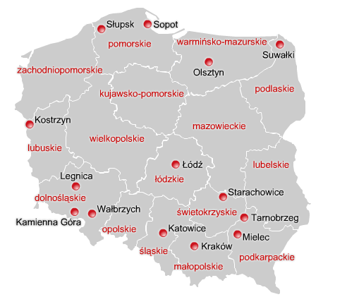
Source: Polish Information and Foreign Investment Agency, URL: www.paiz.gov.pl

Entrepreneurs operating in special economic zones are supported with the following instruments:
- corporate income tax (CIT) and personal income tax (PIT) exemptions,
- land fully prepared for investments offered at competitive prices,
- free assistance in completing investment-related formalities,
- real estate tax exemptions (available in some gminas).

Income tax exemptions granted entrepreneurs operating in special economic zones are so-called regional public aid which is a tool used to accelerate the development of less developed regions of the European Union through supporting new investments and creating new jobs.
Entrepreneurs intending to start economic activity in the special economic zone and benefit from public aid have to obtain a permission issued by the zone’s board of directors. Tax exemptions are granted to selected types of business activity. The right to benefit from tax exemptions are granted entrepreneurs investing in special economic zones under the following conditions:
- entrepreneurs are prohibited from transferring, in any form whatsoever, any property or any part whereof, connected with the investment, for a period of 5 years, and in case of small and medium-sized entrepreneurs – 3 years, from the date of entering of this property or its part into the records of fixed and intangible assets according to income tax regulations;
- entrepreneurs operating in special economic zones are obliged to run business activity for a period of at least 5 years; and in case of small and medium-sized entrepreneurs – no less than 3 years;
- in the event when an entrepreneur is granted public aid on the grounds that it creates new jobs, it has to maintain these jobs for a period of at least 5 years, and if an entrepreneur is a small or medium size entrepreneur – 3 years.
The limits of permissible public aid in particular regions are laid down in the Map of regional aid (cf. map 3 below). According to this map, the basic maximum intensity of regional public aid, shall not exceed the following limits:
- in areas located in several voivodeships of eastern Poland, i.e. in Lubelskie, Podkarpackie, Podlaskie, and Warmińsko-Mazurskie Voivodeships – 50 % of eligible costs;
- in areas located in Pomorskie, Zachodniopomorskie, Kujawsko-Pomorskie, Lubuskie, Łódzkie, Opolskie, Świętokrzyskie, and Małopolskie Voivodeships – 35% of eligible costs;
- in areas located in Wielkopolskie, Dolnośląskie, and Śląskie Voivodeships – 25% of eligible costs.
Owing to the high GDP per capita in Mazowieckie Voivodeship, this region was divided into several sub-regions with the limits of regional public aid varying from 10% to 35%.

Map 3. The map of regional aid in 2014 – 2020
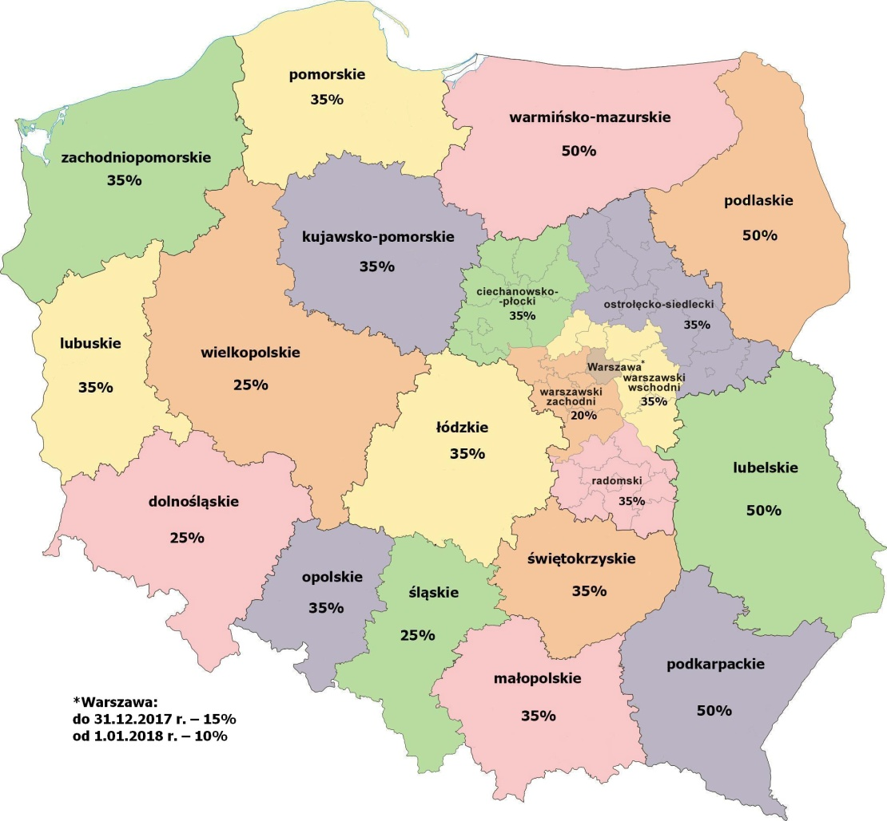
Source: www.europa.eu
The costs eligible for regional public aid for entrepreneurs operating in special economic zones, that is the costs which constitute the base for calculating the maximum amount of tax exemption, are the cost of new investment or the total amount of labour costs associated with the newly employed employees, depending on whether granted tax exemptions are connected with investment or new jobs created by the investor. Investors are allowed to benefit from both forms of support, provided that the total amount of support is not exceeding the limits of admissible regional public aid applicable for this investment. In this case, the limit of admissible aid is determined by multiplying the maximum aid intensity and a higher amount of the costs of new investment or 2-year labour costs resulting from the employment of new employees.
The cost of the new investment are the total investment outlays incurred by the investor, less calculated value added tax (VAT) and excise duty, if the possibility of deductions is provided by specific regulations, borne by the investor within the validity of a permit to operate in the special economic zone for the following:
- purchase of land or the right of land perpetual usufruct;
- purchase or making by the taxpayer of fixed assets provided that these assets, according to binding regulations, have been included into the taxpayer’s property;
- development and retrofit of existing fixed assets;
- purchase of intangible assets connected with the technology transfer through purchasing patent rights, licences, know-how, and/or unpatented technical knowledge;
- the costs related to the acquisition of assets under lease contracts other than land, buildings and structures, shall be taken into consideration only if the lease takes the form of financial leasing and the contract includes the lessee’s obligation to buy the assets upon expiration of the lease period.
Economic effects that special economic zones in Poland have contributed to are varying. The scale of produced results to a large extent depends on how this instrument is used. Therefore, based on previous experiences we can state that the attractiveness of special economic zones for big and medium size investors is determined by the following factors:
- geographical location (more investors have been attracted to special economic zones located in south-western regions of Poland with well-developed infrastructure, located close to big urban agglomerations);
- well designed, attractive offer addressed to potential investors (including availability of land prepared for investments, good cooperation with local authorities), and
- labour market (the size and the quality of available workforce).
Summary
In Poland, the number of enterprises with foreign capital is increasing, in particular in automobile industry, offshoring centres, electronics, and chemical sector. Goods manufactured in Poland are very popular abroad, mainly because of their high quality. A large group of exporters are foreign investors which highly value qualifications and professionalism of Polish economists, engineers, IT specialists and scientists. Foreign investors cooperate willingly with Polish research-and-development centres and scientific institutions. What attracts them to Poland are still relatively low labour costs and high efficiency. Poland offers foreign investors a number of investment incentives, such as special economic zones and EU structural funds. Moreover, the Polish economy has a sound base for stable, lasting development, which is crucial for the influx of foreign investment to the country.

Bibliography
- Bojar E., Bezpośrednie inwestycje zagraniczne w obszarach słabo rozwiniętych, PWN, Warsaw 2001.
- Działalność gospodarcza podmiotów z kapitałem zagranicznym w 2012 roku, Central Statistical Office, Warsaw 2014.
- European attractiveness survey, Ernst and Young, 2010.
- Filipiak B., Kogut M., Szewczuk A., Zioło M., Rozwój lokalny i regionalny. Uwarunkowania, finanse i procedury, Published by: Fundacja na rzecz Uniwersytetu Szczecińskiego, Szczecin 2005.
- Hirschman A. O., The Strategy of Economic Development, Yale University Press, New Haven, 1958.
- Kaldor N., The case for regional policies, Scottish Journal of Political Economy, vol. 17, 1970.
- Rittenbruch K., Zur Anwendbarkeit der Exportbasiskonzepte im Rahmen der Regionalstudien, Duncker und Humblot, Berlin 1968.
- Rosenstein-Rodan P.N., Problems of Industrialization of Eastern and South-Eastern Europe, The Economic Journal, Vol. 53, No. 210/211. (Jun. - Sep., 1943).
- Sektor nowoczesnych usług biznesowych w Polsce, Association of Business Service Leaders in Poland, Warsaw 2014.
- World Investment Report 2013, New York and Geneva 2013.
- Zagraniczne inwestycje bezpośrednie w Polsce w 2012 roku, National Bank of Poland, Department of Statistics, Warsaw 2014.
- www.europa.eu – downloaded on 10 July 2016.
- www.nbp.pl – downloaded on 10 July 2016.
- www.paiz.gov.pl – downloaded on 10 July 2016.
- www.stat.gov.pl – downloaded on 10 July 2016.

Lublin University of Technology, Poland – e.bojar@pollub.pl
Lublin University of Technology, Poland – j.bis@pollub.pl

